­­

**Disclaimer Acceptance Log**

November 8, 2017 - Version 3.5

**Contents**

1 Overview 3

1.1 Supported Versions 3

1.2 Category 3

1.3 Special Considerations 3

2 Deployment 4

2.1.1 Install Relativity application to library 4

2.1.2 Install Relativity application to workspace 4

2.1.3 Upgrading from previous versions 4

3 Workflow 6

4 Input and Preparation 7

4.1 Add and Enable the Disclaimer Agent 7

4.2 Disclaimer Solution Configuration 7

Inputs 8

4.3 Disclaimers 8

Usage 8

Inputs 9

4.4 Reporting 10

User Acceptance 10

Inputs 10

Errors 11

5 Results 12

6 Troubleshooting 13

7 Disclaimer 14

1. Overview

This Relativity Applications allows users to display multiple group specific and/or environment wide disclaimers upon login.

* 1. Supported Versions

This solution is supported in Relativity version 8.1-9.4 with all supported browsers.

* 1. Category

This custom solution consists of the following components:

Relativity script that runs at the workspace level

* Event Handler
* Custom Agent
* Custom Objects
* Relativity Application
  1. Special Considerations
* The first time a disclaimer is displayed after login, it may take 20-60 seconds for the disclaimer service to start. Afterwards, disclaimers will load much more quickly for subsequent users who are eligible to be prompted to accept a disclaimer.
* This application was designed to only be installed in a single workspace
* The disclaimer text field is HTML enabled mainly to allow text colors, bolding & underlines. Take great care in entering HTML because it could possibly open users to scripting attacks and adversely affect the look of the disclaimer container displayed at login.
* Disable the Disclaimer Acceptance Agent before uninstalling the solution.
* Disclaimer Text HTML may be displayed in a raw format on the disclaimer list view, however it will be fully decoded and presented to users in traditional html when prompted to accept disclaimers.
* Custom components may not exhibit the same performance and behavior as native Relativity features.
* While each solution is carefully built and thoroughly tested to work on your version of Relativity, they are not considered core features and are not eligible for the same level of support as the Relativity platform.

1. Deployment
   * 1. Install Relativity application to library
2. Log in to Relativity.
3. Navigate to the Admin/Home section.
4. Click on the Application Library tab.
5. Click on the Upload Application button.
6. Click on the Browse… button next to Application File.
7. Select the file RA_Disclaimer_Acceptance_Log.rap and click Open.
8. Click Save.
   * 1. Install Relativity application to workspace
9. Log in to Relativity.
10. Navigate to the Admin/Home section.
11. Click on the Application Library tab.
12. Click on the application Disclaimer Acceptance Log.
13. Under Workspaces Installed, click on the Install button.
14. Next to Workspaces, click on the ellipsis […] button.
15. Select only a single workspace to install the application to.
16. Click OK.
17. Click Save.
    * 1. Upgrading from previous versions

If you have already installed a previous version of this application, you are required to complete the following steps to ensure preservation of logs, and complete and stable installation.

1. Log in to Relativity.
2. Navigate to the ‘Relativity Applications’ tab in the workspace that contains the application
3. Click the Unlock Application button and click OK to accept the confirmation
4. Click on the Uninstall Application button
5. In the Component Summary section, click the ‘+’ to see the components that are part of the application
6. Uncheck everything under **Object types** **except** the following
   1. Disclaimer Event Handlers
      1. KCD_1042192.EventHandlers.DisclaimerPreSaveEv
      2. KCD_1042192.EventHandlers.DisclaimerPreDeleteEv
   2. Disclaimer Solution Event Handlers
      1. KCD_1042192.EventHandlers.ConfigPreSaveEv

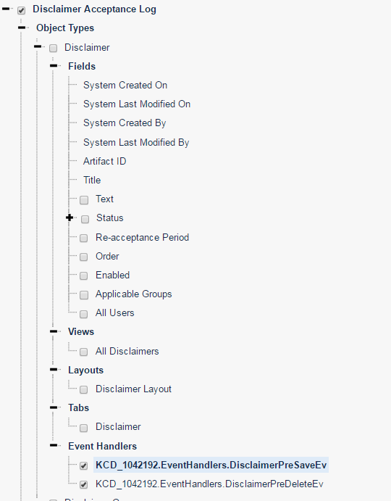

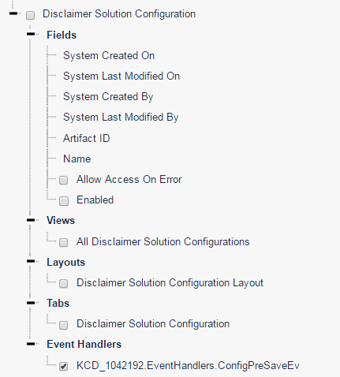

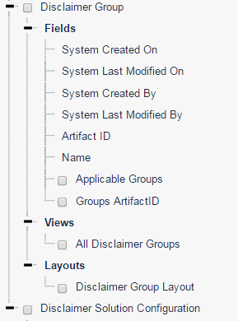

1. Click the Validate Components button to Validate that the selected components can be removed
2. Click the Uninstall button
3. Within the Administration section, navigate to ‘Resource Files’ tab and verify that the following Event Handlers are no longer available.
   1. KCD_1042192.EventHandlers.DisclaimerPreSaveEv
   2. KCD_1042192.EventHandlers.DisclaimerPreDeleteEv
4. Within the Administration section, navigate to the Application Library tab and delete the ‘Disclaimer Acceptance Log’ application by clicking on the Delete button
5. Follow instructions from section 2.1.1 and 2.1.2 to install a new version of Disclaimer Acceptance Log
6. Workflow
7. Add the application to the application library
8. Install the application into a workspace
9. Enable the Disclaimer Acceptance Agent
10. Create a Disclaimer Configuration Object in the workspace
11. Create and enable a disclaimer
12. View user acceptance logs and errors under the Disclaimer Reporting tab of the application
13. Input and Preparation
    1. Add and Enable the Disclaimer Agent
14. Select the Agents tab located at the Admin/Home level
15. Add a new instance of the Disclaimer Acceptance Agent
16. A run interval of 5-60 seconds is recommended and directly affects the time needed to enable/disable disclaimers
17. Enable the agent

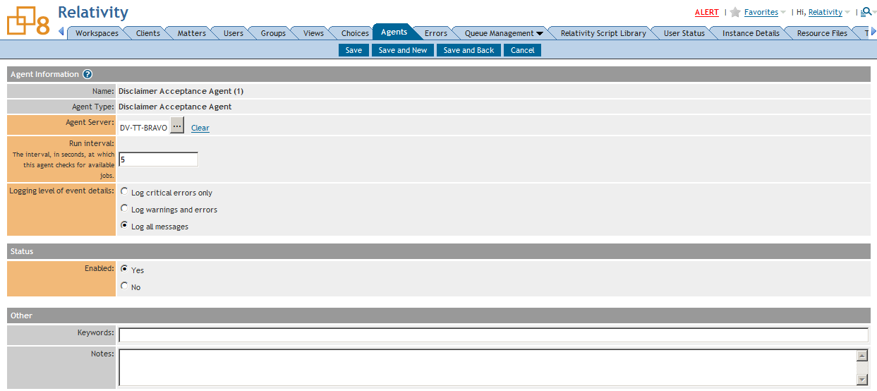

* 1. Disclaimer Solution Configuration

1. In the workspace where the application is installed, select Disclaimer Solution Configuration under the Disclaimer Acceptance Log tab
2. Select New Disclaimer Solution Configuration
   * Note: only the settings from the first configuration object created will be recognized by the application

Inputs

* **Name:**
  + The name of the Configuration Object
* **Enabled:**
  + This field Enables/Disables the solution. The state of the configuration object’s enabled setting takes precedence over whether or not an individual disclaimer is enabled.

Allow Access on Error option:

**Enabled:**

Users are allowed to access Relativity in case an error occurs at the disclaimer page after they log in. The user is able to access Relativity and they will be prompted for the disclaimer they were unable to accept the next time they log in.

**Disabled:**

Users are not allowed to access Relativity when an error occurs at the disclaimer page after they log in. They are presented with a message to contact their system administrator.

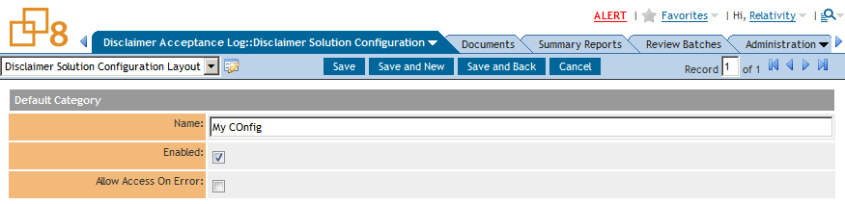

* 1. Disclaimers

Usage

Click the Disclaimer tab to create a new disclaimer. Click New Disclaimer. Enter the input fields below to create a new disclaimer. After it is saved, its status on the view will either be ‘Queued for Activation’ or ‘Queued for Deactivation’. After the agent picks up the newly enabled/disabled disclaimer, it will change the status to ‘Active’ for enabled disclaimers and the status will be blank for disabled disclaimers. Refrain from toggling the enabled option with mass edits because its status won’t be updated by the agent.

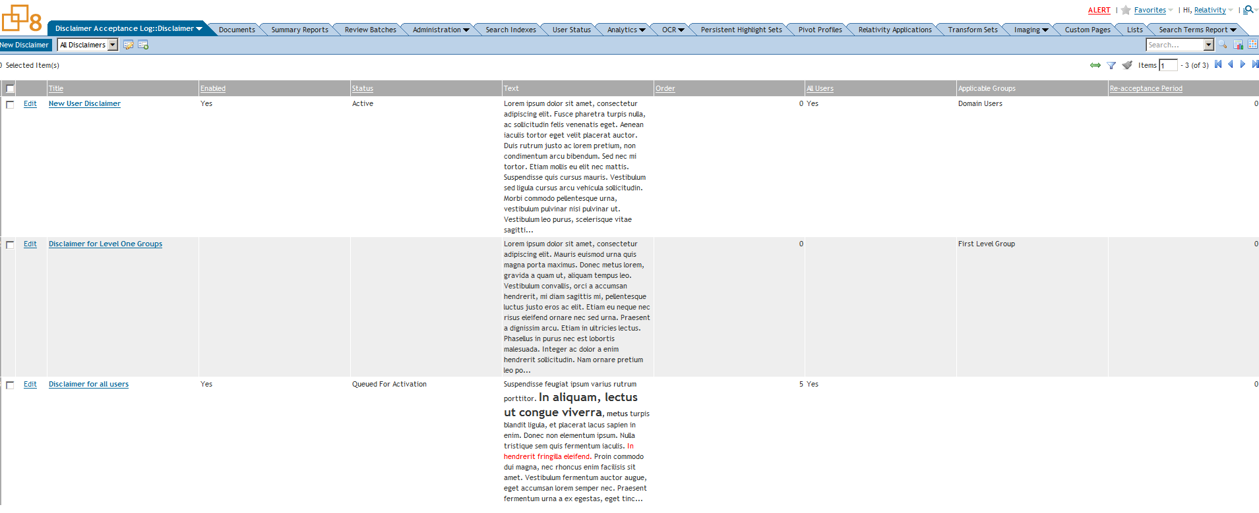

Inputs

**Title**

* + This is the title that will be displayed above the disclaimers

**Text**

* + This is the text field for the disclaimers

**Order**

* + The order number is used to sort disclaimers when a user is eligible for multiple disclaimers

**Enabled**

* + Used as a flag by the Agent to enable the disclaimer for applicable users

**Re-acceptance Period**

* + This field can be used to re-prompt a user to accept a disclaimer after a certain number of days
  + If no choice is selected, users are not prompted to re-accept disclaimers.

**All Users**

* + This setting takes precedence over applicable groups and enables the disclaimer for all users in the environment

**Applicable Groups:**

* + Applies the disclaimer for users only in the selected groups

Disclaimer Groups exist as an internal RDO specific to this application. They reflect the groups that exist in the admin level and are automatically updated by the agent. In order to reflect deleted groups from the admin level, it must be manually removed from any disclaimers in which it is attached.

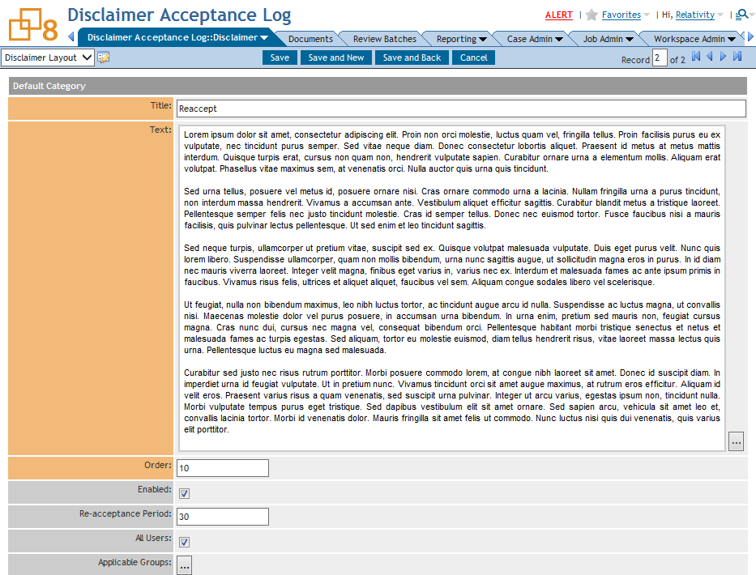

* 1. Reporting

There is a User Acceptance and an error report available under the Disclaimer Reporting tab

User Acceptance

Inputs

* + Disclaimer:
    - Select the disclaimer for the log you would like to view

Note: The log is still available for deleted disclaimers

* + Include Disclaimer Text:
    - Users can determine whether or not they want to display the disclaimer text that was accepted when returning their report.
    - Timestamps are in UTC

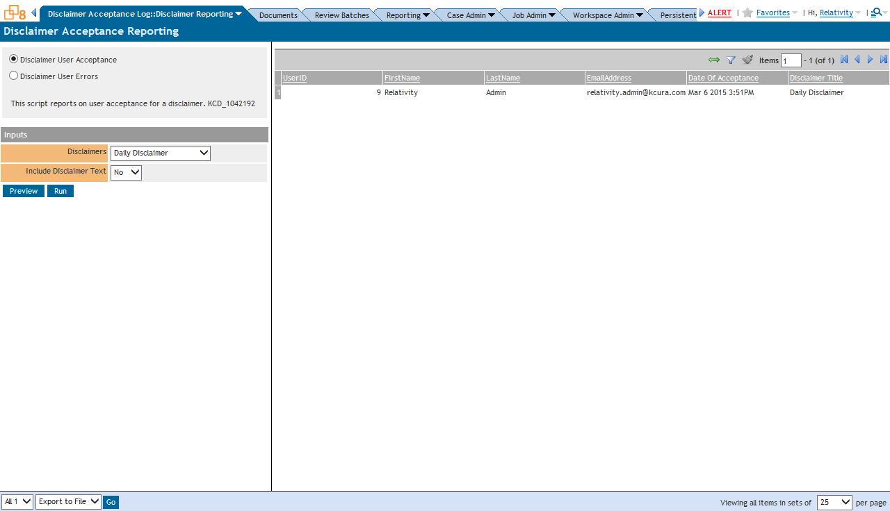

Errors

The User Errors Script displays all errors pertaining to the disclaimer solution that were able to be captured.

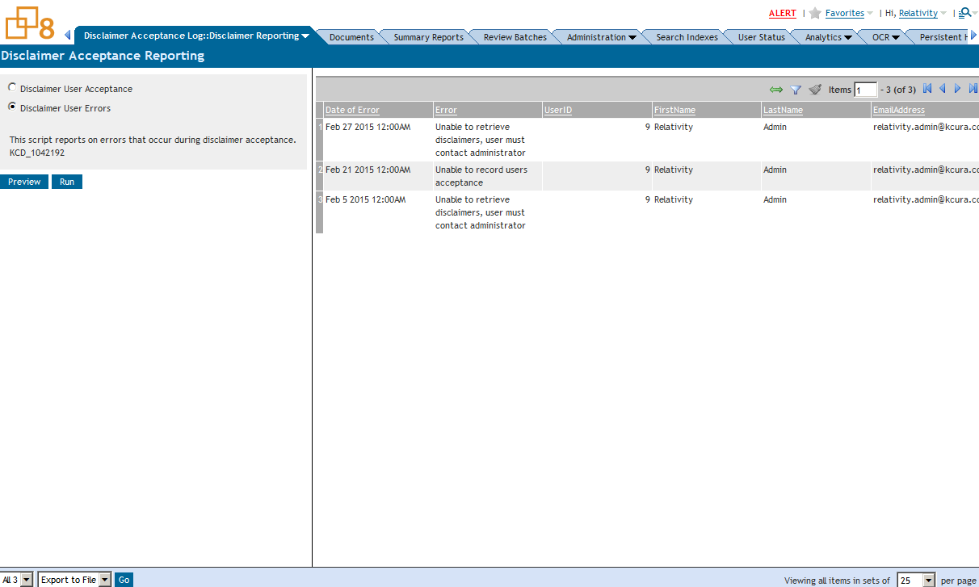

1. Results

Users eligible to receive disclaimers will be prompted to accept them after logging into relativity. Users will never be prompted to accept the disclaimer again unless the re-acceptance feature is used.

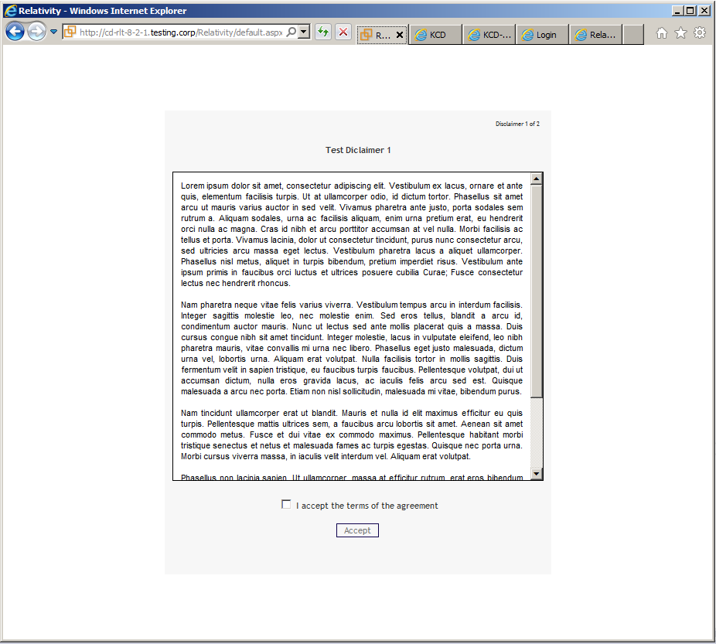

1. Troubleshooting

The whole disclaimer acceptance log solution can manually be disabled outside of Relativity by executing the following command in the EDDS database (Relativity version less than 9.4.315.5) :

UPDATE [EDDS].[eddsdbo].[Configuration] SET [Value] = ' ' WHERE [Section] = 'kCura.EDDS.Web' AND [Name] = 'TermsLinkHref'

The solution can be disabled using the following command in the EDDS database for Relativity version greater than 9.4.315.5 :

update [EDDS].[eddsdbo].[Configuration] set Value = 'false' where [Name] = ‘UsersMustAgreeToTermsOfUse'

* To Enable the solution from this point, make sure that the Agent is running then toggle the enabled switch on the Disclaimer Configuration Object in between the execution time interval of the Agent.

1. Disclaimer

This solution is intended for use only in the Relativity versions specified in this document and run under the guidelines presented. While each solution is carefully built and thoroughly tested to work on the versions of Relativity specified in this document, this script is not a core feature of Relativity and is not eligible for the same level of support as the Relativity platform.

In addition, custom components may not exhibit the same performance and behavior as native Relativity features. Custom solutions do not specify permission settings unless explicitly requested by the client.